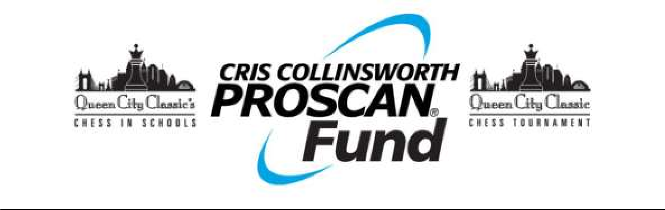

**WAIVER AND RELEASE**

*The waiver and release must be completed by participant OR by parent or legal guardian of student participant if student is under the age of 18. Participants will not be eligible to play without a signed waiver and release on file.*

In consideration of the benefits of my/my child’s participation in the activities of the Cris Collinsworth ProScan Fund (“CCPF”), an Ohio nonprofit corporation, including but not limited to, the activity or activities described below (the “Activity”), I hereby forever voluntarily waive, release, hold harmless, and agree to indemnify CCPF, Queen City Classic Chess Tournament and the tournament venue, along with all the owners, affiliates, members, directors, officers, employees, volunteers and agents of each of these entities, from and against any and all liability, claims, causes of action, or demands, arising out of, or in any way related to, my participation in the Activity or related to any loss, damage or injury (whether direct, consequential, inconsequential or otherwise)that I/my child might sustain or that my/my child’s property might sustain while participating in the Activity. I expressly waive any defense to enforcement of this Agreement arising from any claim of lack of consideration and understand that this Agreement constitutes a legal, valid and binding waiver of my rights and shall be enforceable against me, my family, heirs, successors and estate for any and all purposes.

VIDEO/PHOTOGRAPH/MEDIA RELEASE: By signing below, I hereby authorize and grant the Cris Collinsworth ProScan Fund, the absolute and irrevocable right and permission to use, print, or publish in any medium any photographs, film, videos and all other visual media taken or produced of me/my child associated with the Queen City Classic Chess Tournament for purposes of promotional, marketing, and/or publicity materials of CCPF (including but not limited to use on the Fund’s letterhead and website).

By signing below, I acknowledge that I have carefully read and understand the information stated above and accept all the terms and conditions of this Agreement.

Activity: Queen City Classic Chess Tournament, March 29, 2025

Date

Printed Name of Participant or Parent/Legal Guardian if under 18:

Signature of Participant or Parent/Legal Guardian if under 18:

Cris Collinsworth ProScan Fund

5400 Kennedy Ave, Cincinnati, Ohio 45213 ccpf.org